“Parsed Life” Dark Theme

Last Updated: 20/11/2015

# Dark Editing/ Bright Printing Theme

This theme was designed to be both dark and bright compatible.

## How to Switch Back to Bright Mode

You can easily switch to bright mode by changing the document’s background:

1. Go to DESIGN tab



1. Choose “Page Color” option (on the far right)

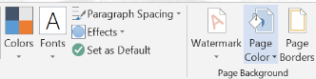

1. Select the top left color (White Background)

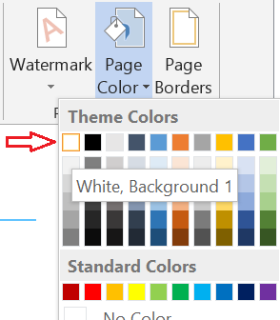

## Theme Release Notes

### Design Notes

* The main font is “Segoe UI Light” which is ink friendly.
* The headings are without fill color in order to be ink friendly and dark/bright mode compatible,
* The headings that are supported are Headings 1 to 4.
* Some shortcut keys:
  + Ctrl+Alt+1 for Heading 1, Ctrl+Alt+2 for Heading 2, and so on (until Heading 4)
  + Ctrl+Alt+0 for “no spacing”
* Hyperlinks color (unclicked & clicked links) were also changed to be dark/bright compatible.
* The Margins and Spacing were reduced to allow maximum page usage.
* When editing the document’s header (by double clicking the top line of this page) its text will appear in black. However, after you’ll finish editing it, the text will return to be grayish.

### Recommended Practices

* If you’re writing documents that are not likely to be printed (A theoretical example, if you write a blog…) you are more than likely to explore bright colors in this theme. These colors are much more vivid in dark mode.
* However, if you plan on creating documents that are likely to be printed, be aware of using colors that will not appear good in bright mode.